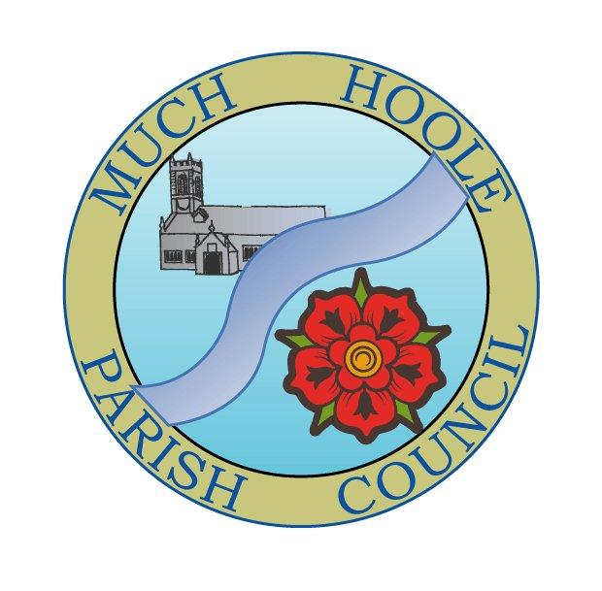
Minutes of the Parish Council meeting held on
Monday 11th April 2022 at 7.30pm. The meeting was held in the Venue, Liverpool Road, Much Hoole.

1. | Apologies for Absence  To receive apologies for absence:  Cllr Woodcock (work commitment)
2. | Declaration of Interests and Dispensations  - Cllr Taylor Village Hall and item re cycle track lease payment  - Cllrs Brown and Houghton in relation to items relating to the Village Hall  - Cllr Hayes items 11 and 9
3. | Minutes of last meeting  Minutes of the 14th March 2022 were agreed and signed
4. | Public Time  One member of the public was present. He asked why the Parish Council’s flagpole had been damaged. He asked why a flag had been flying during high winds and what would be done about those responsible for not removing it in anticipation of high winds. He was told that it was regrettable that the pole had suffered storm damage, but the Council had accepted that such things happen during bad weather.  The same person asked what the agenda item for £231 for a planning application fee related to? He was informed it was in payment for the artwork planning application discussed and agreed at a previous meeting  The same person asked why the Council had set aside what he viewed as a large sum of money for community improvement projects when people are facing cost of living rises, and would the Council set a reduced budget next year?. Firstly, he was advised that the budget was set in December 2021, before the current cost of living issues arose. Secondly, the Council was unaware that CIL money would become available so the budget was set to a level that would allow the Council to fulfill its role in improving the village. Lastly, he was advised that the size of next year’s budget would be discussed at the next budget setting meeting at the end of the year. The size of the budget would be set with all those issues in mind and in the light of how much money the Council has left and how much it is able to carry over into the next financial year.
5. | Cycle Track  A lot of work has been done on the cycle track by Chris Hewitt and a team of volunteers, helped by a ground works contractor. The track has been re-surfaced and re-designed to make a better route for younger riders. A hardcore base has been laid for a bench but the concrete is not yet down.  Cllr Taylor informed the meeting that he had been advised of flooding issues emanating from his land at the cycle track and that he had investigated it but was unable to identify where the flooding might be coming from. He is currently awaiting further discussion with LCC to resolve any issues.
6. | Finance  To authorise payment of the following:  - It was resolved to pay the Clerk in sum of £240 net pay (for March)  - It was resolved to pay the Clerk mileage expenses in the sum of £7.20  - It was resolved to pay HMRC in sum of £60 PAYE (for March)  - It was resolved to approve payment of £398.86 to LALC for annual subscription  - It was resolved to approve £231 planning application fee (by cheque)  - It was resolved to make a £500 payment by way of the previously agreed annual grant to support upkeep of St Michael’s Church Burial ground  - It was agreed to approve to pay Alan Taylor cycle track rent of £90 as per lease. Cllr Taylor took no part in this item)  - The proposal to purchase a new flagpole was not approved. It was decided that the original flagpole could be repaired rather than spending money on a new oneTo note end of year bank balances and bank reconciliation  - The remittance from SRBC in sum of £8,156.11 for CIL was noted  - It was noted that the Clerk has opted to remain outside of the Local Govt Pension scheme and the Council has fulfilled its legal obligations with the Pension Regulator.
7. | Reports from / notice of other meetings attended by Councillors or Clerk  Cllrs Lea and Woodcock attended an LCC ‘Highways Special’ on Saturday 19th March. It was mainly a serries of presentations from LCC officers but there was some disappointment that it did not help to address the communication and co-operation issues that exist between LCC and Parish Councils. It was agreed that the link to LCC reporting should be included on the MHPC website.  It was also agreed that the Parish Council would put a link to Community Roadwatch on its website.  Cllr Hayes was due to attend the Parish Chairs meeting on 21st March but it was cancelled due to Covid  Cllr Houghton attended the LALC area committee meeting on 24th March 2022 and circulated a report. It was agreed that given the comments relating to neighbouring Parishes experience of SPID devices, the Clerk would gather further information and bring the issue of SPID devices back for further consideration.
8. | Community led projects  - In relation to the small patch of land at Birchfield and Liverpool Old Road, the owners have now been identified.  - It was agreed to contact the WI to plan the planting of Red White and Blue bedding plants around the village.  - The Village Hall update was presented and reported that the car park work is underway, the hall is being well used by numerous groups and as yet the accounts cannot be closed as work is still underway.  It was suggested that greater publication of the Council’s ability to provide grants, support and funding should be made via websites, posters and social media.  It was also agreed that the current grant application criteria to access Council grants may be too restrictive for newly formed groups and should be reviewed at a future meeting to make them more user friendly.
9. | Footpath repairs  A recent survey of footpaths has identified a number of paths in need of repair to stiles and bridges. These have been reported to LLCC PROW team but remain ‘pending’ after several months. Cllr Cocker has looked into FP 22 which has some serious defects and advised that the responsibility to repair lies with the landowner rather than the Council. It was agreed that the Council will identify the landowner and may consider collaborative efforts to make the repairs.  It was also agreed that way-markers would be obtained from LCC and the Parish Council would make arrangements to have them replaced where they are missing.  Cllr Cocker will have his details forwarded for inclusion in the PROW forum.
10. | Queens Jubilee  Banners have been designed to advertise events and jubilee celebrations, but costs had exceeded original estimates and the parish Council was asked to make a contribution towards these extra costs. This will be placed on the next agenda as a proposal.
11. | Variation in Speed limits  There is a proposal to impose a 50mph speed limit along the full length of the A59 through Much Hoole where it is currently de-restricted. The Councillors had varying views on the proposal and chose not to make a response as a Council, but individual Cllrs would be free to offer their own personal views via the consultation route. It was also agreed that notice boards, websites and social media would all bring the proposals to as wide an audience as possible during the consultation period.
12. | Training  There were no current training opportunities relevant to Much Hoole Councillors.
13. | Planning  The application was noted
14. | Items for the Next Agenda (for information only)  Annual Parish Council Meeting, Election of Chair and Vice Chair, Internal audit report and annual returns if complete. Renewal of General power of competence. Request for £140 funding for Jubilee events, Review of Grants policy, Spring planting, Further details on SPID effectiveness if available, Footpaths, Consideration of land purchase at Birchfield.
15. | Date of Next Meeting  The Parish Council agreed the date of the next meeting as 7.30pm 9th May 2022 at the Venue

